
ОБЩЕСТВО С ОГРАНИЧЕННОЙ ОТВЕТСТВЕННОСТЬЮ
«ЛАЗЕРТАГ»

ПАСПОРТ

Смоленск

LLC LASERWAR

SPECIFICATION

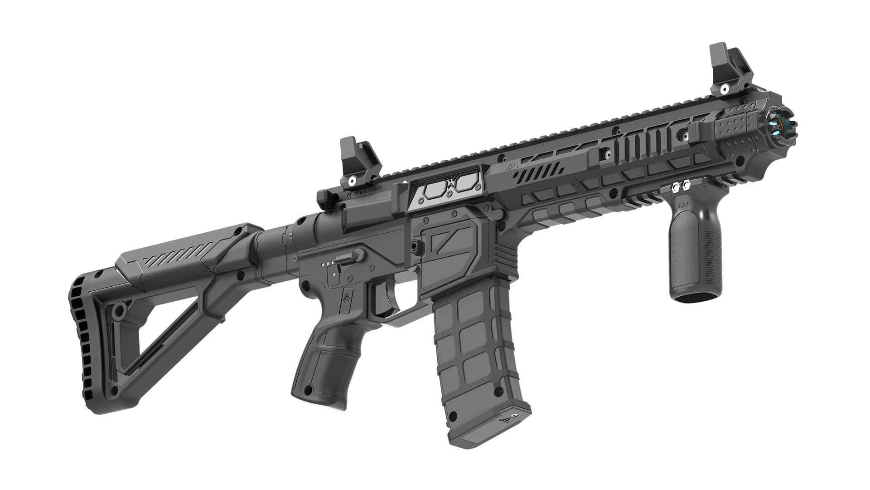

AR-15 RANGER
play set SPECIAL edition

Dear Customer!
Thank you for choosing our products! LLC LASERWAR would like to assure you that you will enjoy the purchased device and it will serve you long. This slip defines the terms of the guarantee.
This guarantee slip period is 24 months from the purchase day provided that the terms and conditions set out in this guarantee are complied with.

- Contact details
Official website:
www.laserwar.com

e-mail:
info@laserwar.com
help@laserwar.com Date of purchase:_____________

Skype:
info-laserwar.com
help@laserwar.com

_____________________
stamp signature

Equipment version Serial number

v.9 SmartRGB

v.10 X-GEN Wi-Fi

v.11 ALFA Feedback OLED

2
11
- Application
The play set AR-15 RANGER of the SPECIAL editon is a light-and-sound rifle designed for playing laser tag.

- Technical specifications
Weight | 1,3 kg
Length | 72 сm
Accumulator type | For v.9 – Li+; 7,4 V; 2200 mAh  For X-GEN – Li+; 7,4 V; 3000 mAh
Battery charger type | Automatic, Li+
Type of Bluetooth adapter | the receiver sensitivity -80 dBm  the radio signal max power, +4dBm  The radio signal frequency -2,4 GHz
Continuous operation time | Up to 30 hours
Effective firing range | 120 - 250 m
Software | LASERTAG configurator

- Delivery set ***
№ | Name | Unit type | Amount
1. | Light-and-sound rifle | pcs. | 1
2. | Product specification | pcs. | 1

Information about repair works during the guarantee period (filled out by the repair centre)

Date:__________________  Maintenance carried out: _____________________________________________________________________  Repair centre stamp | Date:__________________  Maintenance carried out: _____________________________________________________________________  Repair centre stamp
Date:__________________  Maintenance carried out: _____________________________________________________________________  Repair centre stamp | Date:__________________  Maintenance carried out: _____________________________________________________________________  Repair centre stamp
Date:__________________  Maintenance carried out: _____________________________________________________________________  Repair centre stamp | Date:__________________  Maintenance carried out: _____________________________________________________________________  Repair centre stamp

3
10
- Description and operation
  - Construction
Laser tag game set AR-15 RANGER of the SPECIAL edition consists of two parts – a light-and-sound rifle and a headband with defeat sensors.
The communication between the weapon and the headband is achieved by means of Bluetooth technology.
The construction of the game set AR-15 RANGER of the SPECIAL edition is presented in Scheme 1.
Scheme 1 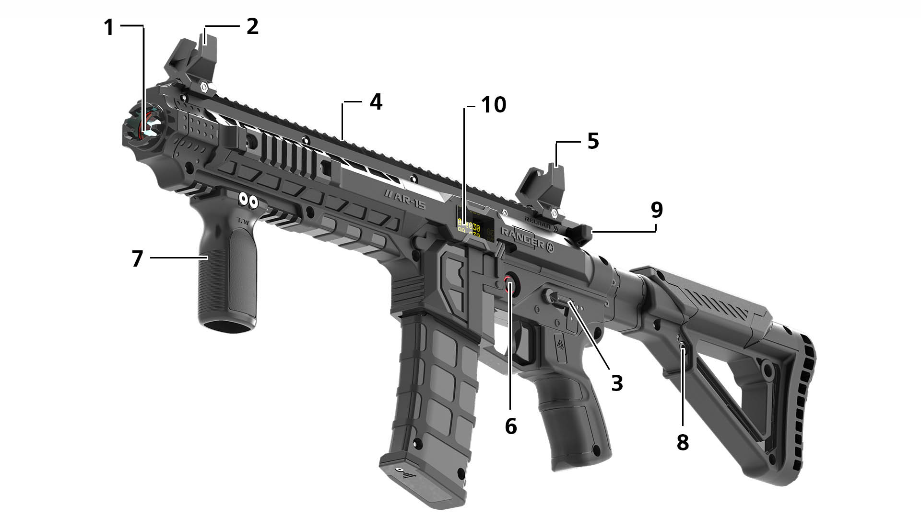
1 – optical system.
2 – back sight.
3 – switch of shooting modes.
4 – additional equipment mount bar.
5 – fore sight.
6 – advanced protection switch lock.
7 – tactical grip
8 – charger inlet
9 – bolt handle
10 – OLED-display

Guarantee terms and conditions:
1. The guarantee comes into force upon presenting of this slip, with a confirmed by a repair center date of purchase displayed.
2. These guarantee promises cover only the devices purchased from an official representative of LLC LASERWAR, or its official dealer.
3. This guarantee does not cover products in the following cases:
- if the customer does not follow the directions outlined in the User’s manual;
- in case of damage;
- if any objects or liquids get inside of the device.;
- if it gets damaged by pets;
- unauthorized access to the units and details of the device;
- abuse or misuse, including failure to use this product for its normal purposes;
- any cause beyond the control of the company, Force Majeure (natural catastrophes, fire, accidents, etc.);
- if the device fails due to incorrect connection, voltage fluctuations, and/or improper care.
4. Should it happen that you loose your guarantee slip, you will not be issued a copy.

4
9
  - Setting up the 10th generation equipment
See the 10th generation equipment exploitation manual:
https://drive.google.com/file/d/1905ZwWY4lOyp2kgPCSVE1AETAkO1-g2C/view?usp=sharing

Changing tactical and technical characteristics of 9th generation equipment
The tactical and technical characteristics of the device can be changed by using the uniform settings program “LASERTAG-configurator”, which is presented in Picture 1
Picture 1
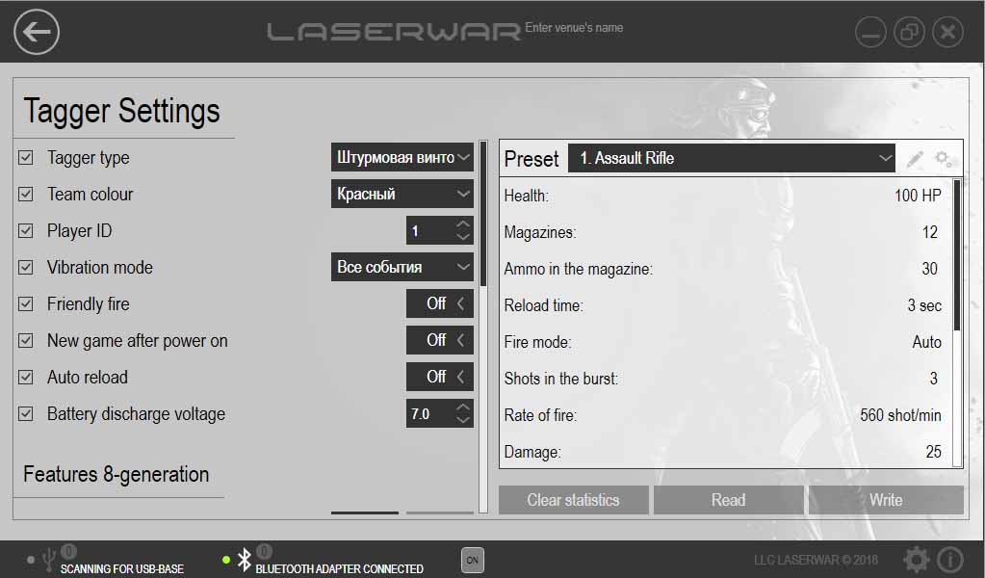
Connect a Bluetooth base to a PC (unless your PC is equipped with a built-in Bluetooth adapter); activate the rifle.

The equipment must be stored in a well-ventilated room at a temperature of +18°С to +30°С, air humidity 45% to 65%.
The equipment must be charged before storing (ideally, at the nominal voltage of the accumulator).

- Guarantee promise
The manufacturer guarantees reliability of the LASERWAR individual set provided the user complies with all the product use requirements. The manufacturer promises to replace or repair an individual set of equipment provided that the user complied with the rules of transportation, storage, use and paid for the delivery of the faulty equipment to the service center.
The guarantee cover for battery chargers, speakers, infrared modules is 14 DAYS.
ATTENTION! If the battery is used incorrectly (wrong battery charger is used to charge the equipment), the accumulators will not be covered by the guarantee!

Visit our website www.laserwar.com to read the full version of the user’s manual by LLC LASERWAR.

5
8
6
7
The headband does not have to be switched on. Bluetooth connection and the number of connected devices will be displayed in the main window of the configurator. Select the required preset and press the Record button. In the window that opens all the connected devices will be displayed, as well as their ID, weapon type, version of firmware, serial number. Press the Update button when required (if no devices have been located).
Select the play set you require by putting a tick on the left hand side of the product description. Press the Record button. After the settings recording has been confirmed reboot the play set.

  - Activating the device
To activate the AR-15 RANGER play set of the SPECIAL edition one must switch on the rifle and the headband. They communicate with each other and will enter the standby mode – the light diodes of the headband will start flickering. After that, one must send the “New Game” command using a remote.
The device is now ready for operation.

- Using your device
1. Weather conditions. We strongly advise that you do not use the equipment in poor weather conditions and at a temperature below -20°С.
Make sure no liquids get inside of the item. If this happens stop operating the device and allow it to get dry at room temperature for at least 2 hours.
You should never charge the equipment that has been exposed to low temperatures. You have to allow the electronic equipment to warm up at room temperature, and allow the condensation, produced due to sudden weather conditions change, to evaporate.
2. The accumulators. Lithium ion accumulators are used as a source of energy in the AR-15 RANGER play set of the SPECIAL edition. Only a universal automatic Li+ battery charger can be used to charge the device.
You must connect the charger to the gun first, then to the mains.
There is a special indicator to help control the charging process. If the accumulator is uncharged the light diode glows red; when it is fully charged the colour changes to green.
Attention! Guns must be recharged immediately after use under constant supervision at a temperature above 0°С for a maximum of 2 hours.
3. The headband. When using headbands you must make certain you use the special fabric bands that protect the electronic components from humidity. If the band becomes wet during use, this may cause the electronic equipment to fail – the band must be dried immediately.
Besides, while you are using the bands it may happen that the caps that protest the sensors get cracked. In such cases the caps must be replaced. The bands must be recharged not later than 80 minutes after the game has been over.
The equipment must be stored in a well ventilated room at a temperature of.

